DARRON GORDON

[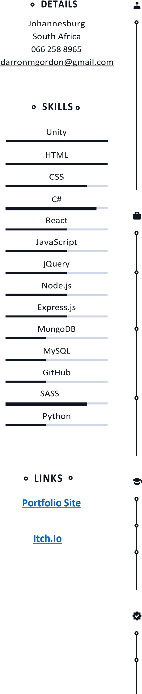](http://www.darrongordon.click)

# JOHANNESBURG, SOUTH AFRICA 066 258 8965

Hardworking and self accountable. I have extensive experience in Unity, C#, mono and network Behaviour. I am skilled in Web-Development and Web3 blockchains.  
I have worked on Building automation controls and networks for studio’s and pharmaceutical factories HVAC control’s.

# EMPLOYMENT HISTORY

**Freelance Web Development and game design**

January 2020— Present

**Operations Manager at DarronAir, Johannesburg**

January 2019 — January 2020

**Technician at I.P.L Engineering, Johannesberg**

January 2014 — January 2015

• Ammonia Refrigeration

**Technical Manager at S.C.M.C Delta Controls, Johannesburg** January

2007 — January 2019

* Delta BMS/BAC
* HVAC

**Freelancer, Johannesburg**

* Game-Jams / Hackathon
* Game-Development
* Web-Development
* App-Development EDUCATION

# Education

PCEP, Python Institute N1, Technisa, Johannesburg

Apprentiship, SCMC

Delta BAC/BMS Apprenticeship.

# Skills

**-Unity 2D & 3D**

* **2D and 3D Game Design**
* **MonoBehaviour**
* **NetworkBehaviour(Fish-net, Mirror, UNet)**
* **Windows/ Web-GL(Html5) / Android Builds**
* **VFX(Particle system, VFX Graph, VFX Shader)**
* **Web3 Block-Chain integration**
* **New and old Input systems**
* **A-star Pathfinding**
* **Scriptable Objects**
* **Code design patterns (Finite state machine, singleton, Observer, Pooling ect..)**
* **Animations(keyframe, Rigging)**

**-Web & JS**

* **HTML**
* **CSS, SASS, SCSS (FlexBox, Bootstrap)**
* **React.JS**
* **React Native**
* **Canvas & iframe**

**-Design**

* **Photoshop / Krita**
* **Spine**
* **Blender**
* **Unity**

**-Noteworthy**

* **1st Place MFG Web3 NEAR block-chain Game-Jam**
* **www.darrongordon.click**